**DAILY ONLINE ACTIVITIES SUMMARY**

|  |  |  |  |  |  |  |  |  |
| --- | --- | --- | --- | --- | --- | --- | --- | --- |
| **Date:** | **07/06/2020** | | | | | **Name:** | **NAIPUNYA VINOD NAIK** | |
| **Sem & Sec** | **IV SEM & A SECTION** | | | | | **USN:** | **4AL18CS050** | |
| **Online Test Summary** | | | | | | | | |
| **Subject** | | **N/A** | | | | | | |
| **Max. Marks** | | **N/A** | | **Score** | | | **N/A** | |
| **Certification Course Summary** | | | | | | | | |
| **Course** | **FUNDAMENTALS OF DIGITAL MARKETING** | | | | | | | |
| **Certificate Provider** | | | **GOOGLE** | | **Duration** | | | **40 HRS** |
| **Coding Challenges** | | | | | | | | |
| **Problem Statement:1)** [**Write a C++ Program to swap two numbers using friend as a bridge concept.**](https://github.com/orgs/alvas-education-foundation/teams/2nd-year/discussions/106) | | | | | | | | |
| **Status: EXECUTED** | | | | | | | | |
| **Uploaded the report in Github** | | | | | **YES** | | | |
| **If yes Repository name** | | | | | <https://github.com/naipunya-naik/lockdown-coding/blob/master/C%2B%2B%20CODING/Swap_07-06-2020.cpp> | | | |
| **Uploaded the report in slack** | | | | | **YES** | | | |

Online Test Details: (Attach the snapshot and briefly write the report for the same).

NO INTERNALS CONDUCTED.

Certification Course Details: (Attach the snapshot and briefly write the report for the same)

CERTIFICATION COURSE NAME:- FUNDAMENTALS OF DIGITAL MARKETING



TODAY, I SUCCESSFULLY COMPLETED THE COURSE OF FUNDAMENTALS OF DIGITAL MARKETING UNDER GOOGLE CERTIFICATION.

Coding Challenges Details: (Attach the snapshot and briefly write the report for the same)

PROBLEM STATEMENT 1:- Write a C++ Program to swap two numbers using friend as a bridge concept.

Top of Form

Bottom of Form

|  |
| --- |
| Note- Don't make use of temp variable while swapping. Program should use the concept of **friend function** ***Example***  **Input** a=10 b=20 **Output** a=20 b=10 |

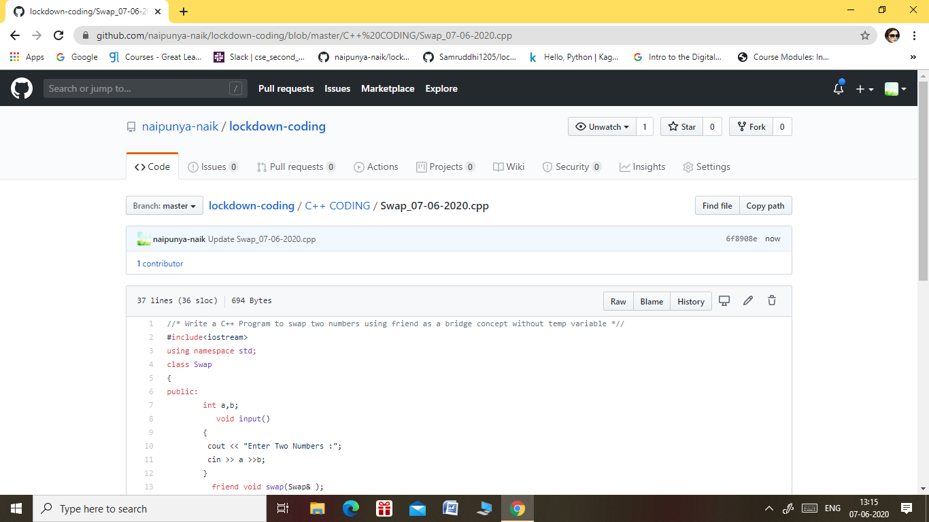

GITHUB REPOSITORY LINK:-

<https://github.com/naipunya-naik/lockdown-coding/blob/master/C%2B%2B%20CODING/Swap_07-06-2020.cpp>